# Spark Ignition Engine Lab

Brandon Lim

9/10/2024

**Figure 1a.** Measuredtorque versus crankshaft speed for the spark ignition engine at fully open throttle.

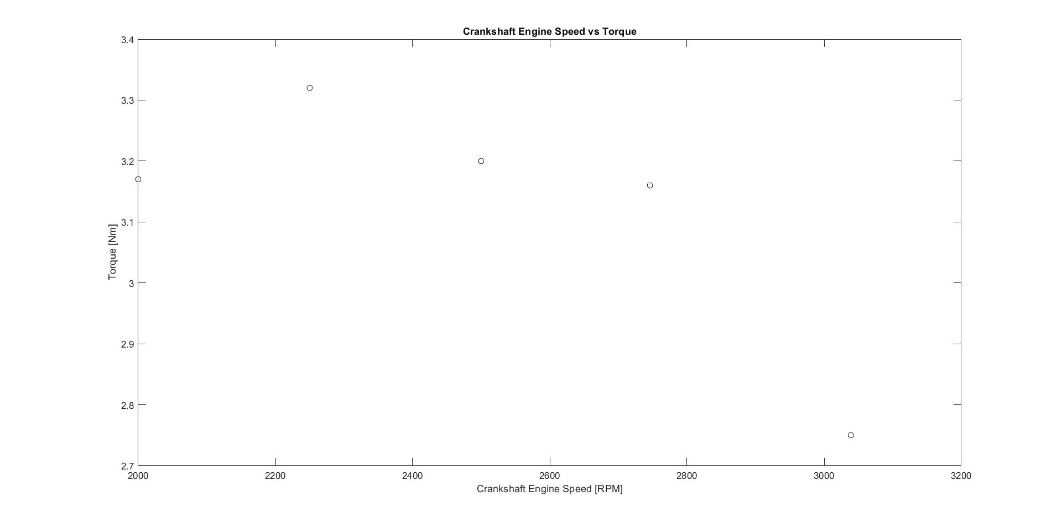

**Figure 1b.** Brake power and total power versus crankshaft speed for the spark ignition engine at full throttle. The markers indicate the experimental measurements. The black line represents the total theoretical power available, based on the Otto cycle using the air-standard model at the same conditions as those measured in the experiment.

**Figure 1c.** Thermal efficiency versus crankshaft speed, comparing the measurements and theory. The theory is based on the Otto cycle using the air-standard model at the same conditions as those measured in the experiment.

**Figure 1d.** Work rate terms in the energy balance of the engine versus crankshaft speed, as based on the experimental measurements.

**Figure 1e.** Mean effective pressure acting on the piston head versus crankshaft speed, as based on the experimental measurements.

Short-Answer Questions

**2a.** *State the value of the following energy ratios (in terms of a percentage) averaged over the entire range of engine speeds examined: , , and . Discuss how the frictional/inertial loss compares to the miscellaneous heat lost to the surroundings, and how this affects the overall thermal efficiency of the engine. [2–4 sentences]*

The average percentage of the energy ratios for , , and across the entire range of engine speeds is 10.74%, 6.5%, and 91% respectively. The frictional/inertial losses are negligible compared to the miscellaneous heat lost to the surroundings therefor the thermal efficiency of the engine is very poor compared to the mechanical efficiency.

**2b.** *Write one sentence for each of the items below related to engine efficiency. [3 sentences total]*

*→  State the average mechanical efficiency of the engine (averaged over the range of crankshaft speeds measured), and compare this value with the typical mechanical efficiency of an electric motor having an equivalent power rating (1–2 hp).*

*→  Write a statement that compares the calculated thermal efficiency with that of an ideal Otto cycle, by quantifying the discrepancy () with a percentage, as follows*

*→  State three things that were neglected in the ideal model of the Otto cycle that might contribute to such a discrepancy.*

Three things that are neglected in the ideal model of the otto cycle are non-isentropic processes, non-constant specific volume heat addition, and non-constant specific volume heat rejection where as the 4 stroke engine has changing temperature’s, and changing specific volumes for heat addition and changing specific volume for heat rejection which all have themal ineffiencies.

The discprenecy between the calculated thermal efficiency of the engine with an ideal otto cycle is 89.5%, 87.9%, 88.4%, 88.7%, and 87.7% for speeds of 3000, 2750, 2500, 2250, and 2000 respectively.

The average mechanical efficiency of the engine was 62% while the typical mechanical efficiency of an electric motor with 1-2 hp is around 75%.

**2c.** *Based on your calculations for the mean effective pressure (MEP), estimate the average force acting on the piston head during the cycle when the engine is operating at 2600 RPM. State your answer in units of both N and lbs. Include this calculation in your Matlab code and have the code display the result to the screen. [1 sentence]*

*Force = 907.21 Newtons = 203.94 lbs*

**2d.** *Carbon dioxide (CO2), a greenhouse gas, is released into the environment from the exhaust of spark ignition engines. A diagram of the carbon lifecycle is shown below, illustrating how auto emissions tend to alter the natural balance by creating excessive carbon dioxide in the atmosphere. Spend some time to research (using the internet, textbooks, or other sources) solutions for reducing CO2 gas emissions from combustion engines. For example, some technologies can help increase engine efficiency, thereby reducing CO2 emissions. State one operation or hardware modification that could be implemented to improve the efficiency of a spark ignition engine, such as turbo- charging, inner cooling, split-fire spark plugs, variable valve timing, etc. Explain how this modification works to improve engine efficiency and describe some of the challenges associated with implementing this modification in practice. [4–6 sentences plus at least one reference]*

Turbo chargers work by spinning an air intake fan with the exhaust gasses produced by combustion. This air intake fan then shovels more air into the combustion chamber of an engine which can improve the performance of an engine by creating more combustion. By improving the performance of the engine and recycling the wasted exhaust gas to drive the process, CO2 emmisions are reduced because less combustion is needed to perform the same amount of work. A challenge of implementing this modification to actively reduce CO2 emissions globally is the acceciblity to turbo-charged vehicles for sale. In 2008 the percentage of cars sold with a turbo charger was 24% compared to the 72% in 2020. This is a great increase over the years but there is still a large 28% of vehicles being sold that aren’t already equipt with a turbocharger.

Reference:

https://www.turbodynamics.co.uk/green-technology#:~:text=The%20basic%20concept%20of%20a,over%20a%20non%2Dturbocharged%20engine.